# **Assignment**

# **Dockerizing a Java Application and Deploying it on Kubernetes**

**Task 1: HelloWorld.java**

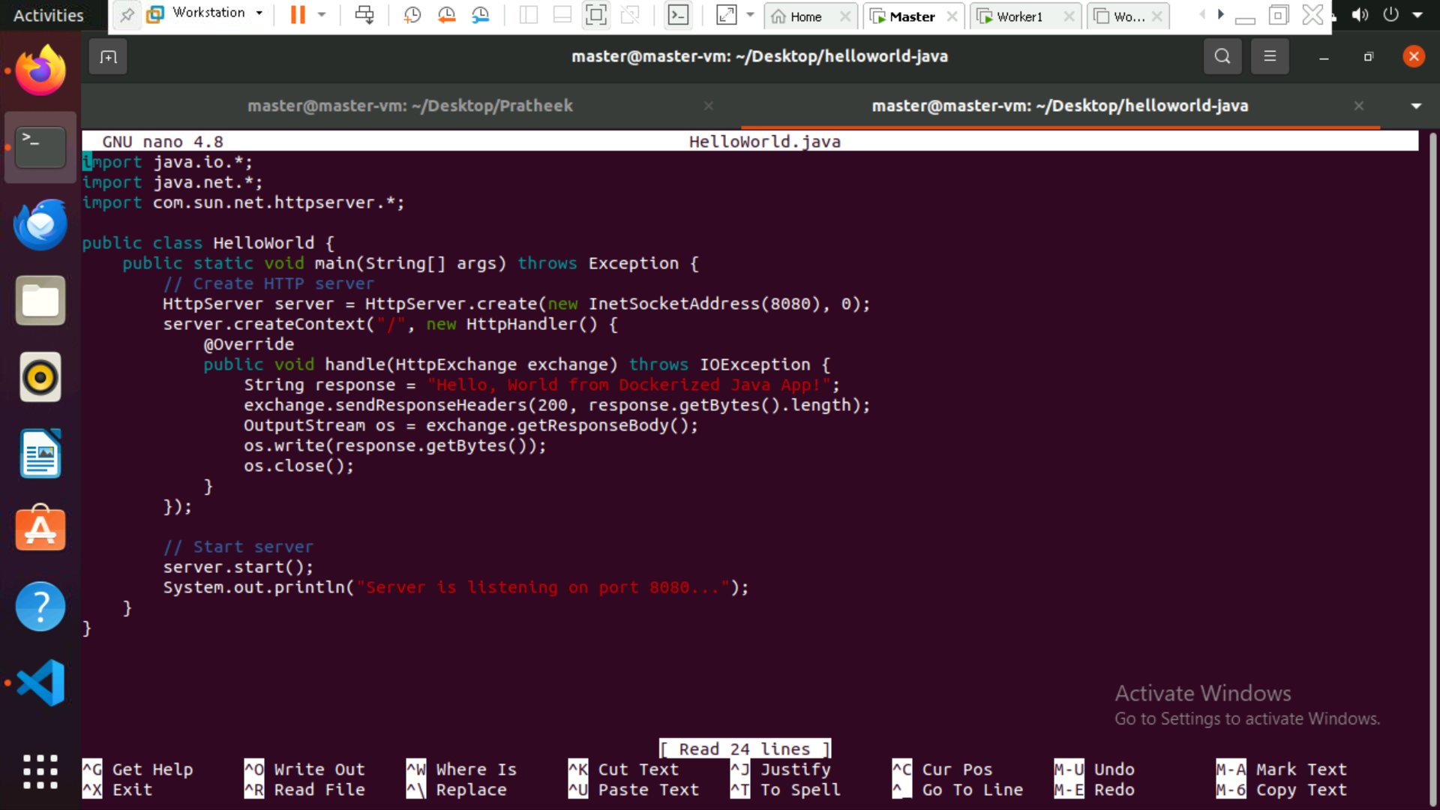

**Task 2: Define a Dockerfile**

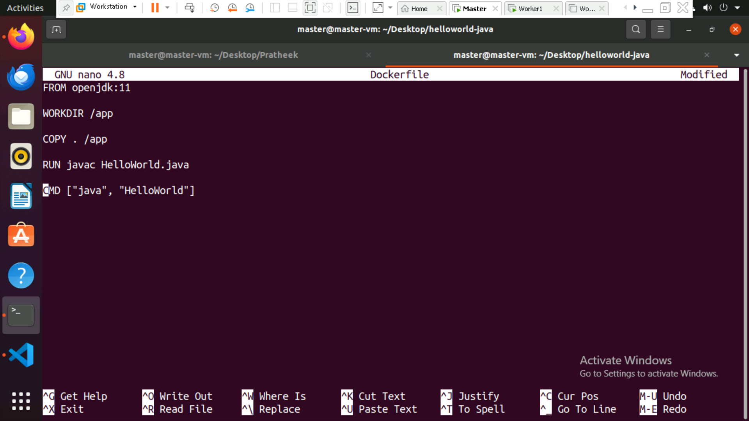

**Task 3: Build and Push Docker Image**

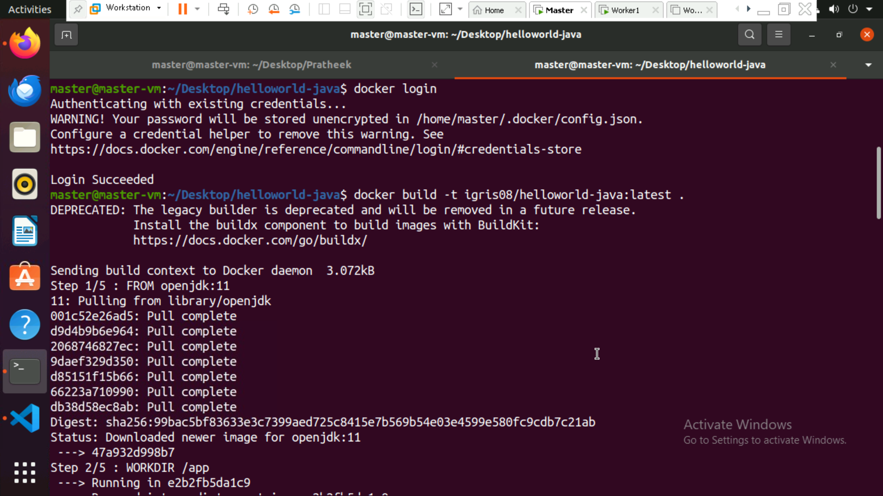

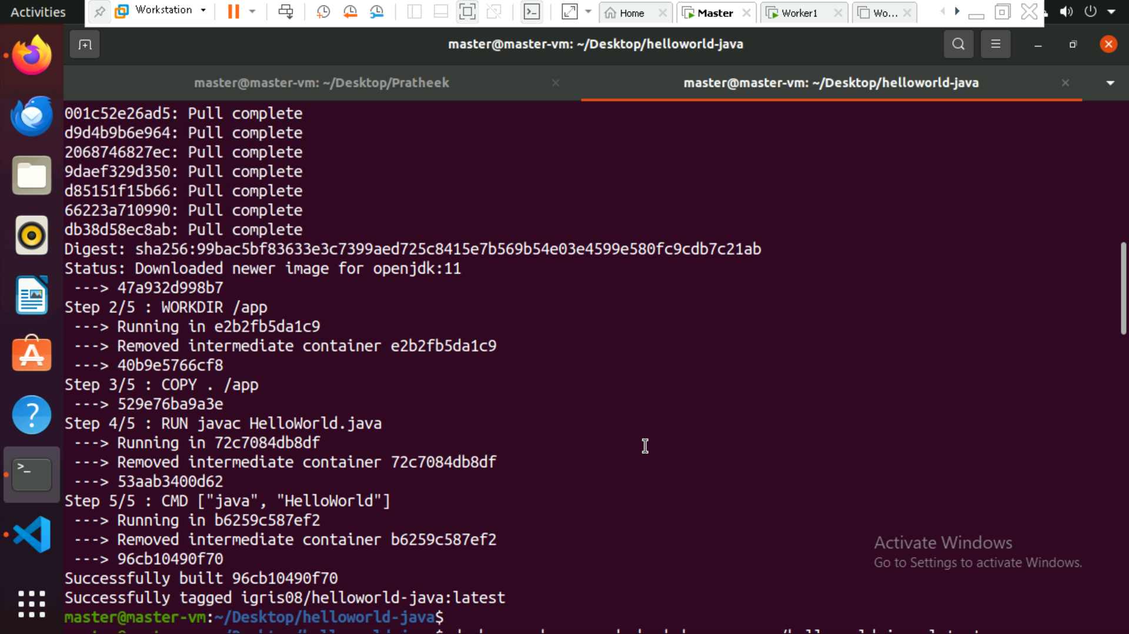

**Push docker image**

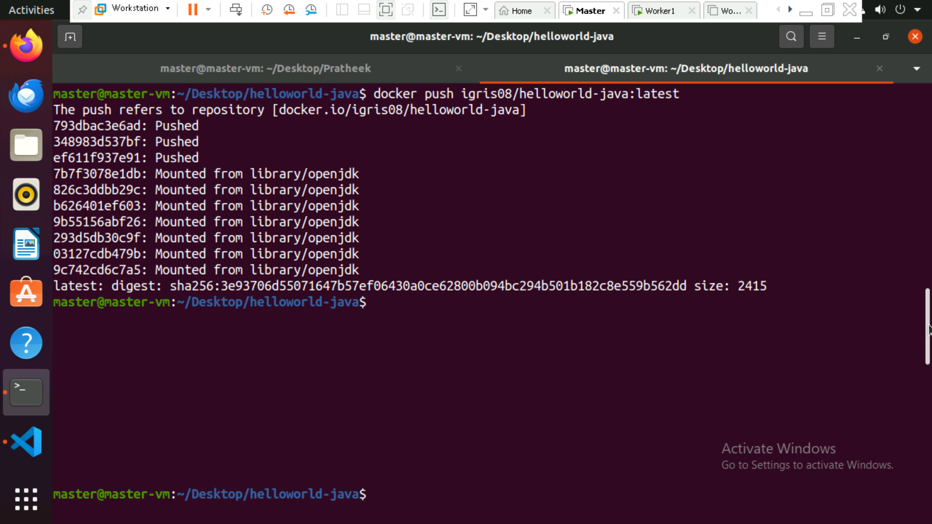

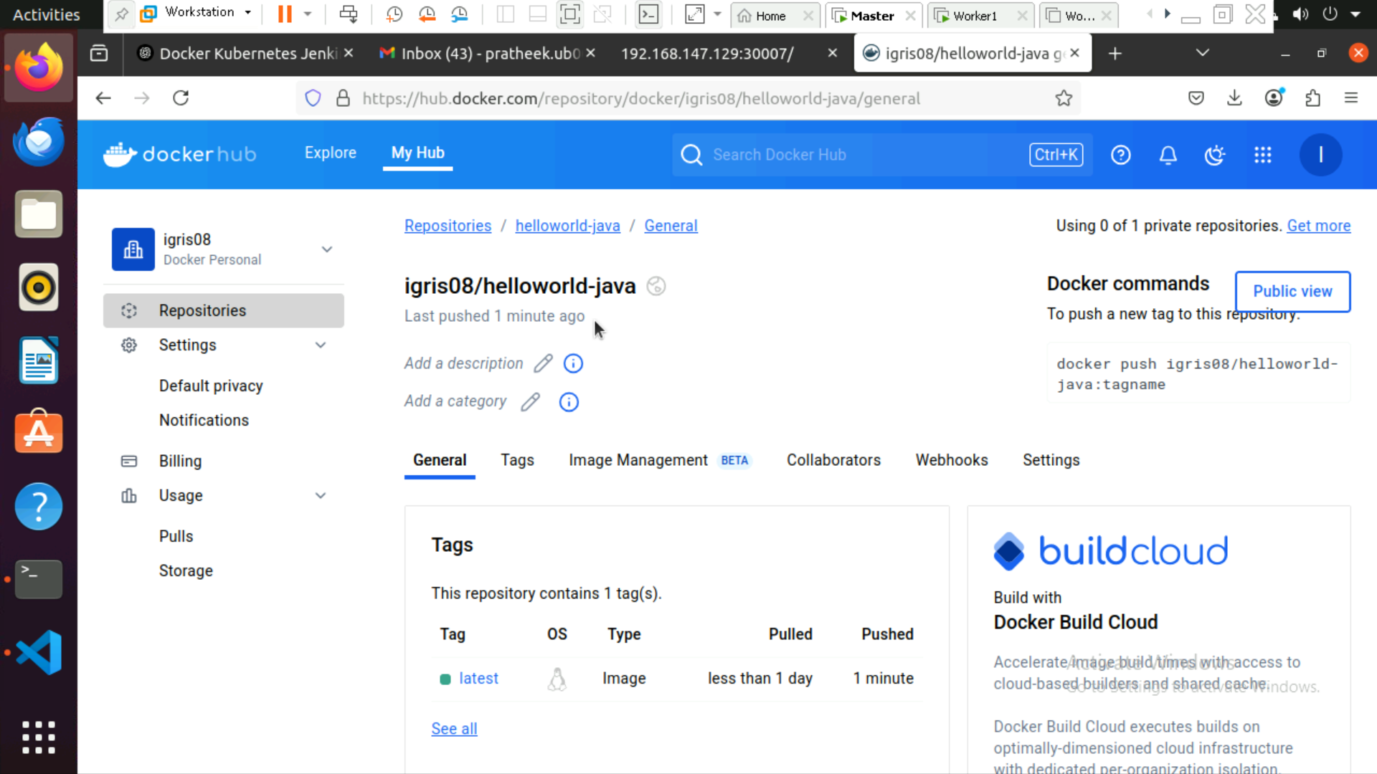

**Task 4: Create a Kubernetes Deployment**

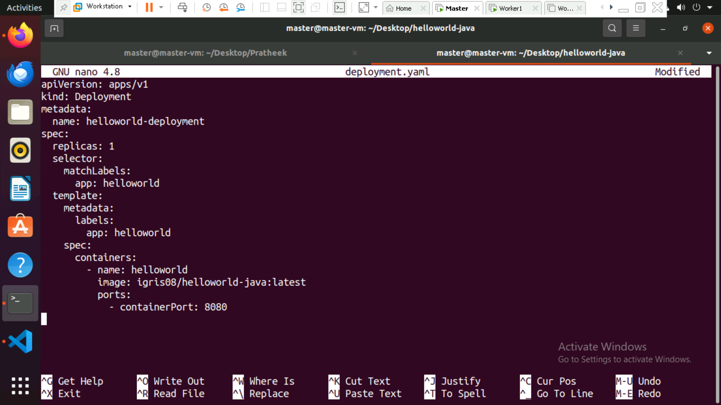

**Applying the deployment**

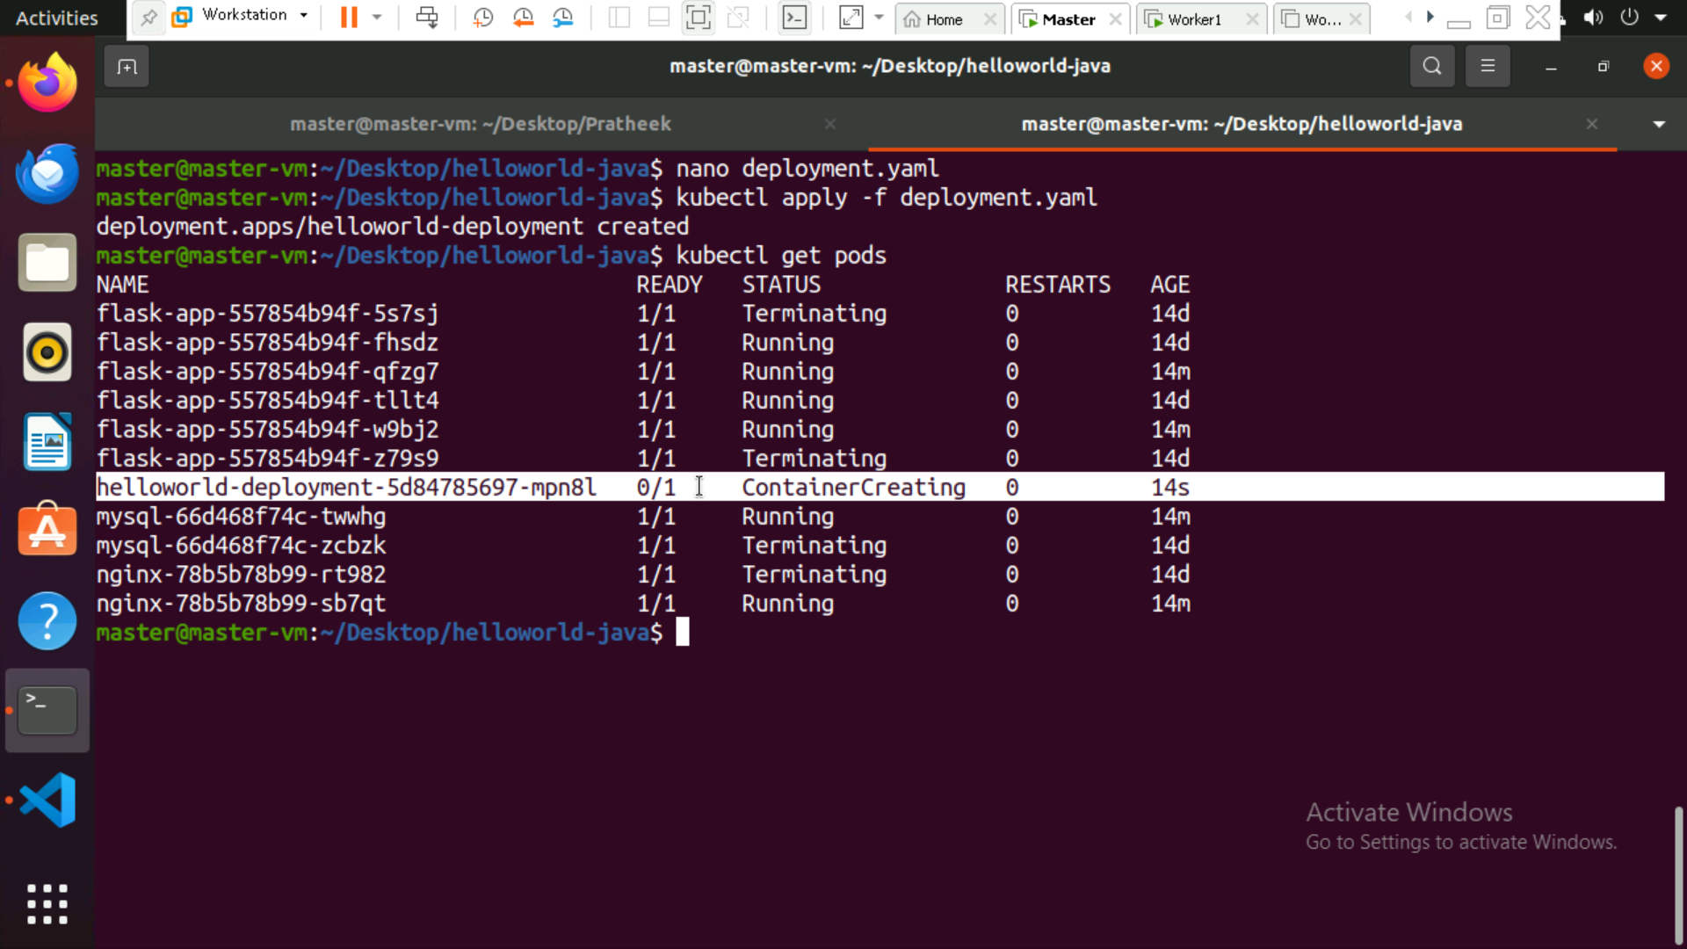

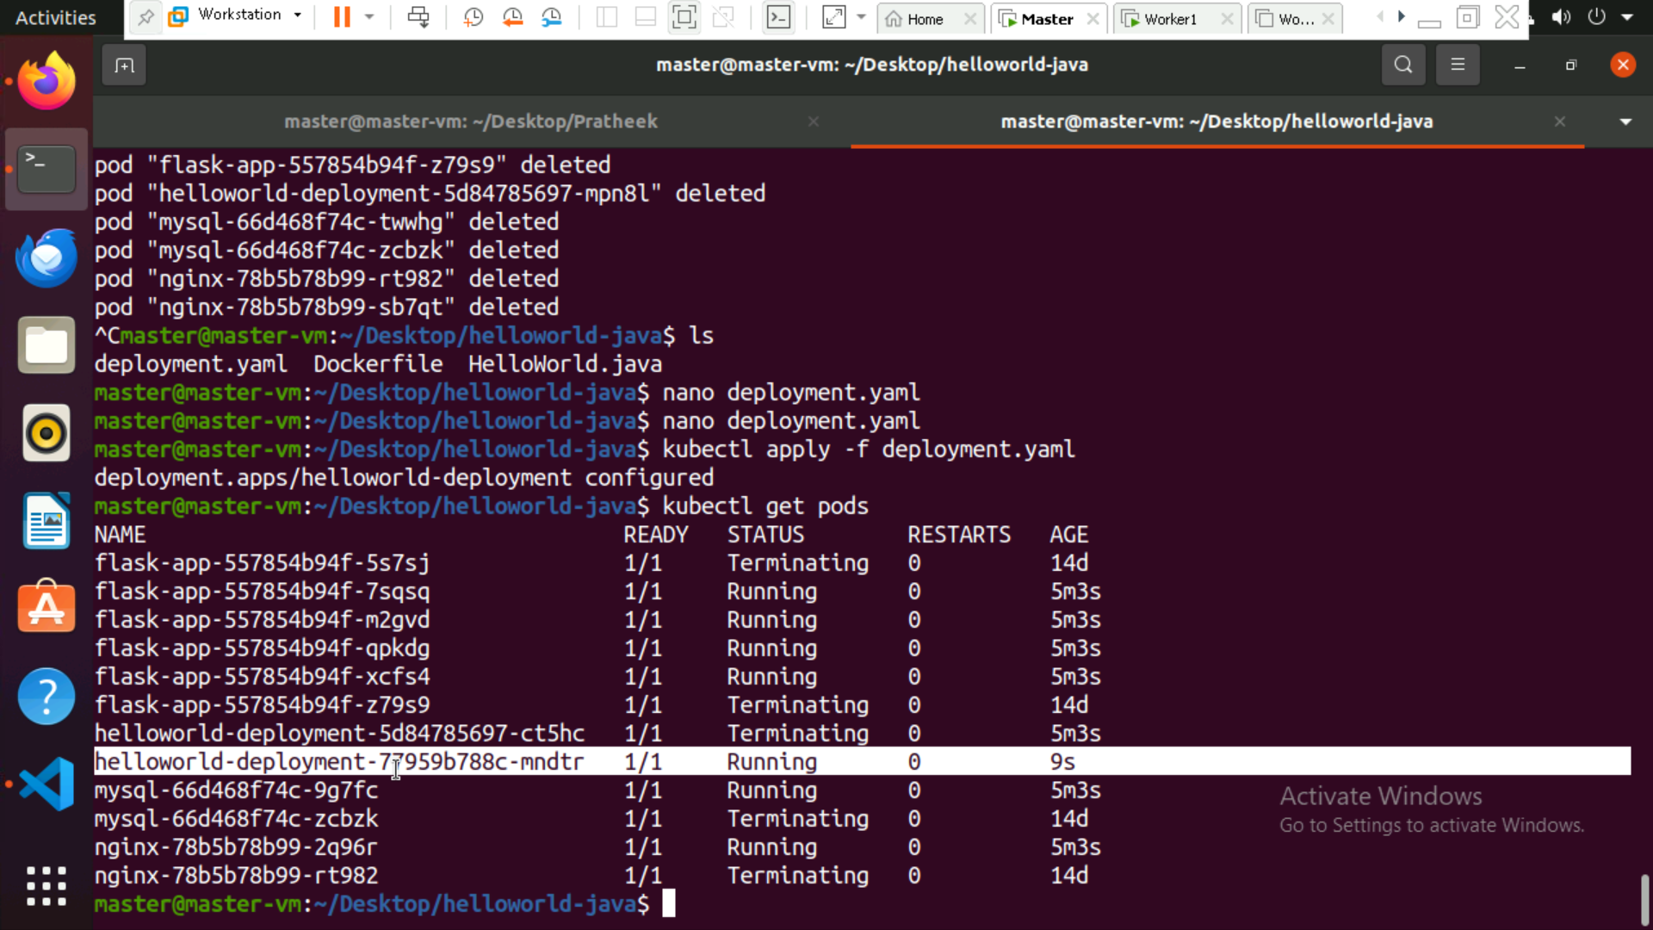

**Task 5: Scale Up and Scale Down**

Scale out to 3 replicas:

*kubectl scale deployment helloworld-deployment --replicas=3*

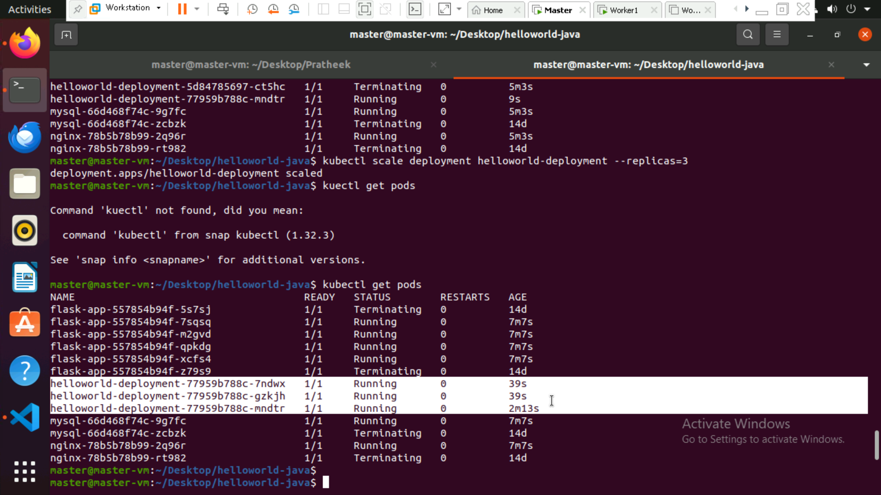

Scale down to 1 replica:

kubectl scale deployment helloworld-deployment --replicas=1

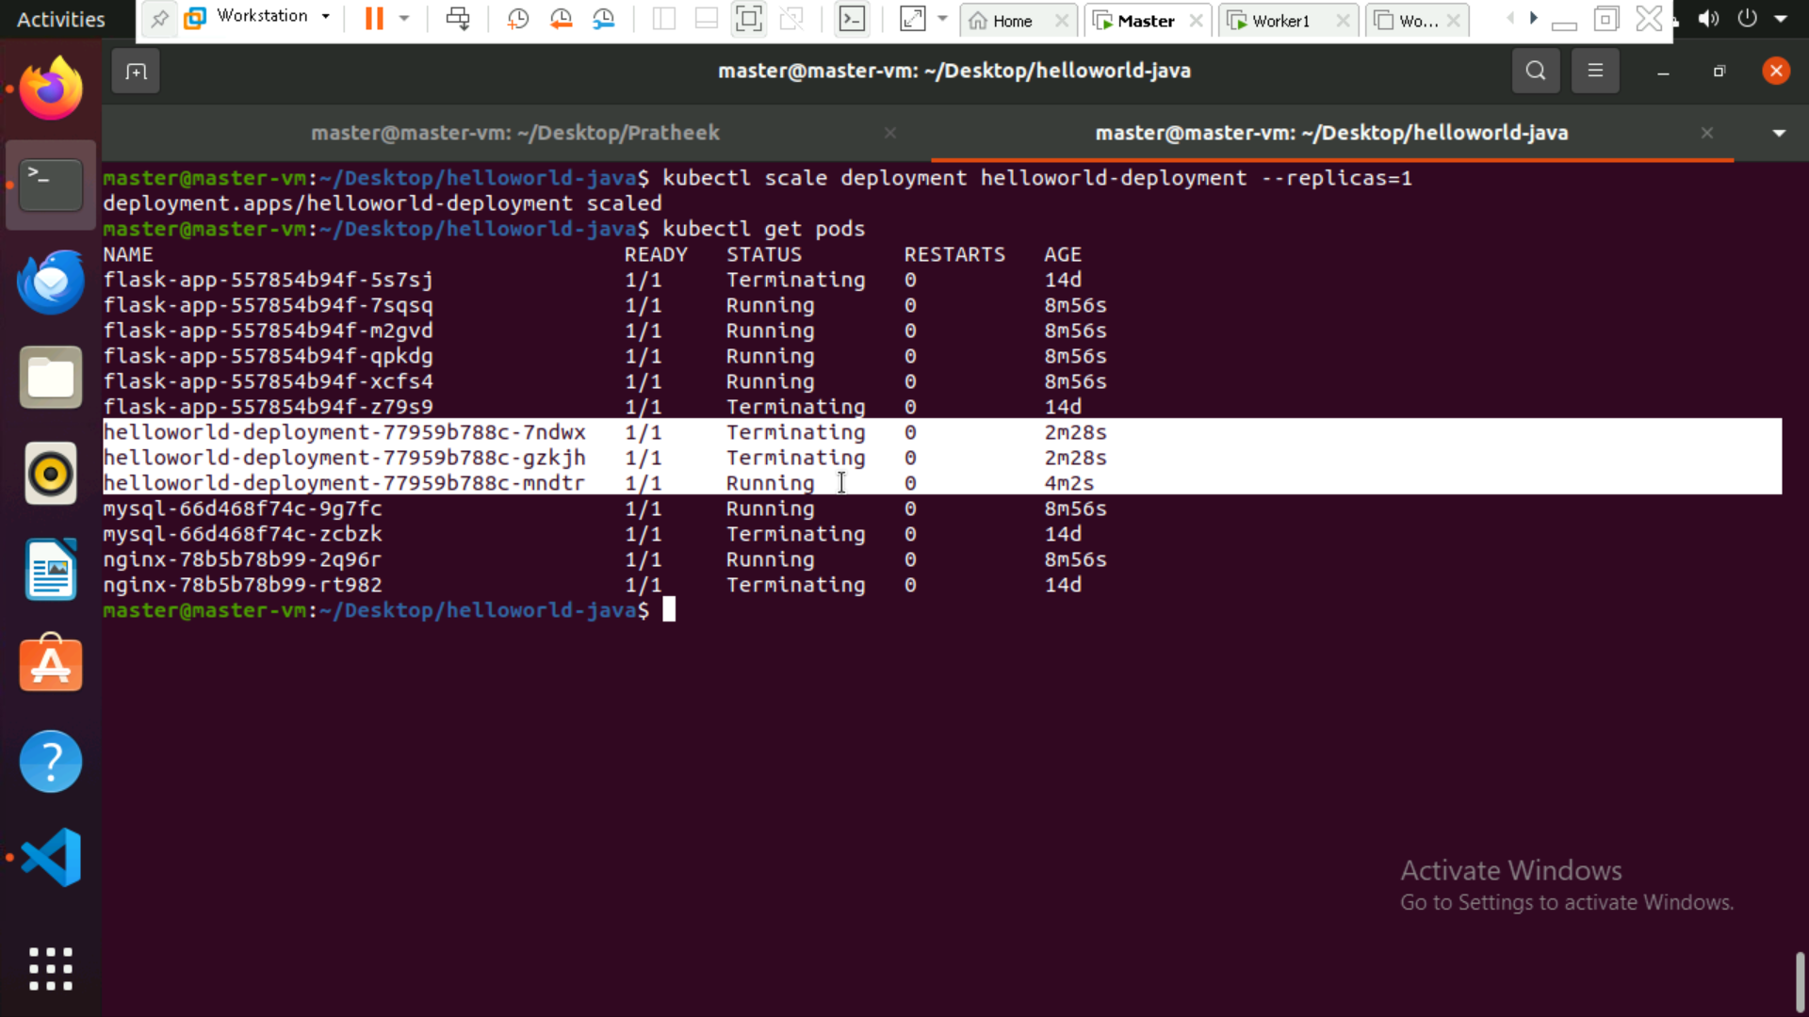

**Task 6: Expose the Service Using NodePort**

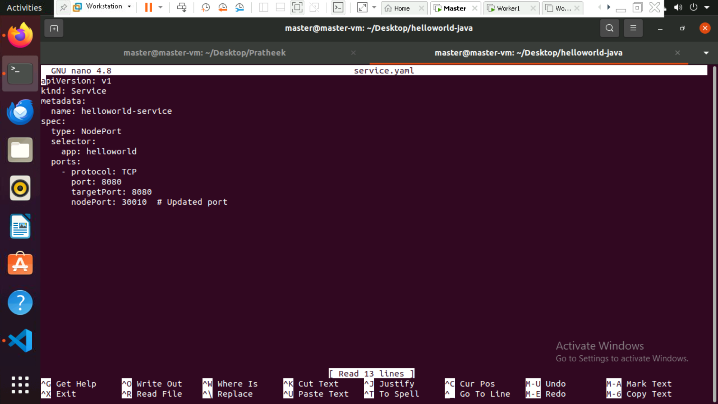

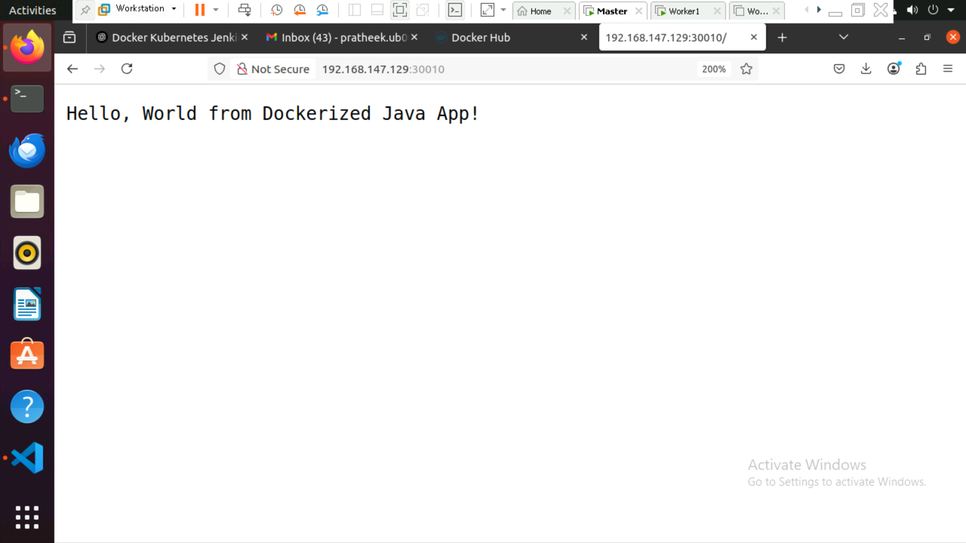

**Task 7: Automate Deployment Using Jenkins**

Install Jenkins, create a Freestyle Jenkins Job, and configure GitHub webhooks to automate deployment.

